**Create a Snapshot and Cloning of a VM and Test it by loading the Previous Version/Cloned VM**

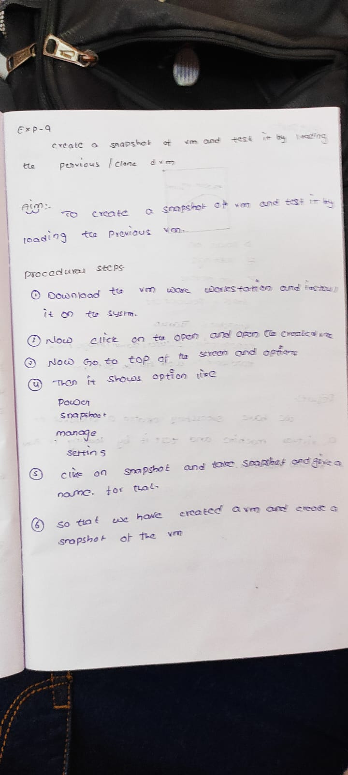

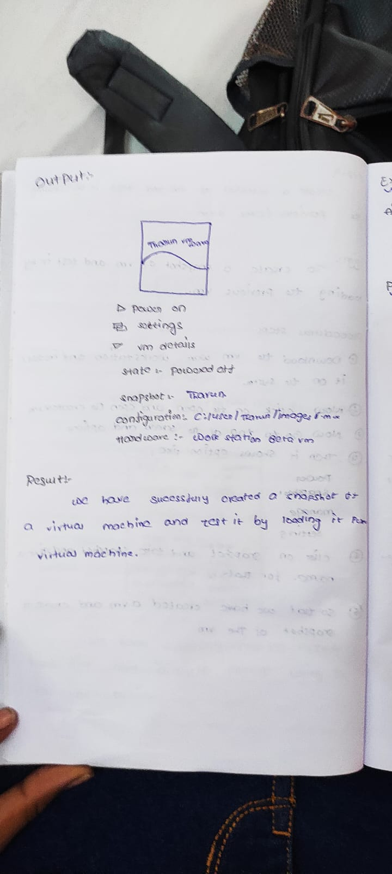

**Click on manage option in that there are snapshot option clikon it**.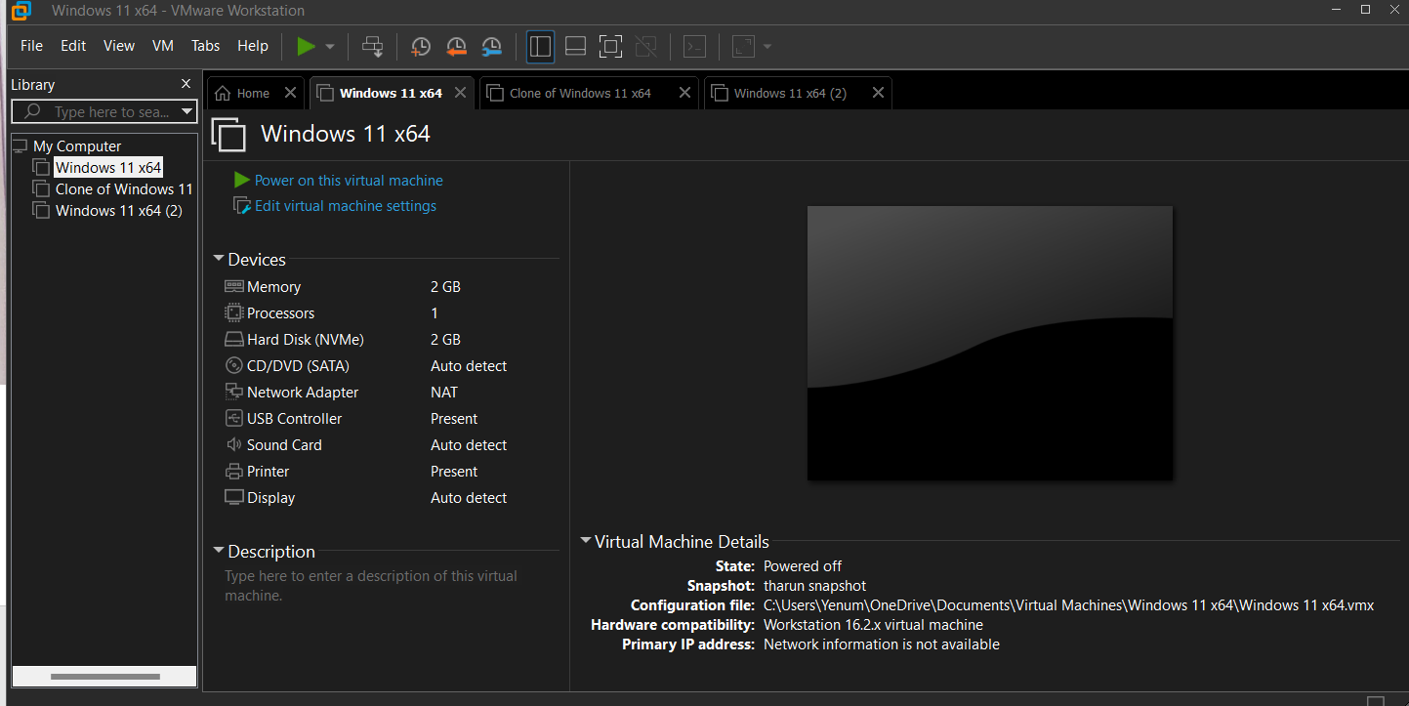

**Out put:** ****s